Jimmy Tran

Panther ID: 002-11-0395

Bourgeois

10 March 2017

Assignment 3

1. Source IP address: 192.168.1.102

TCP Source Port Number: 1161

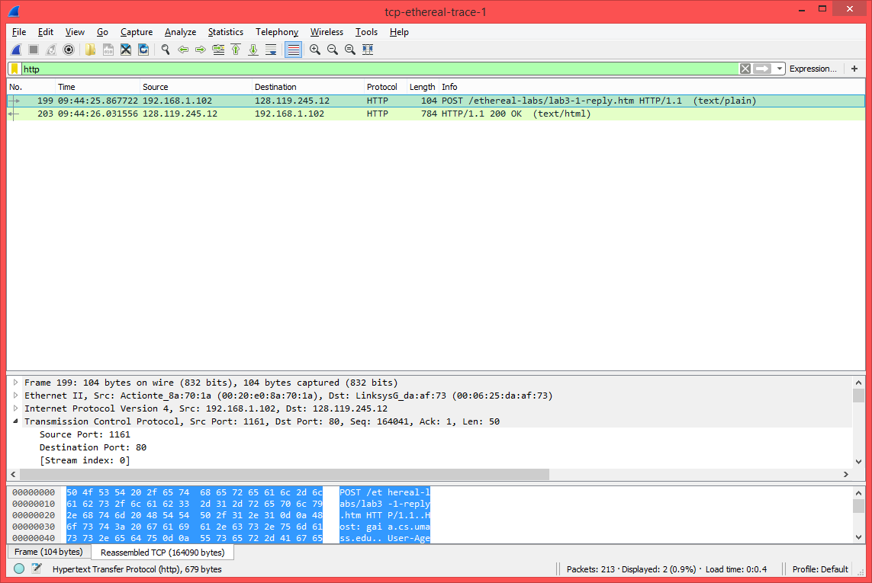

1. Destination IP address: 128.119.245.12

TCP Destination Port Number: 80

See Screenshot above as I used it for both problems.

1. Source IP Address: 192.168.0.110

TCP Source Port Number: 51123

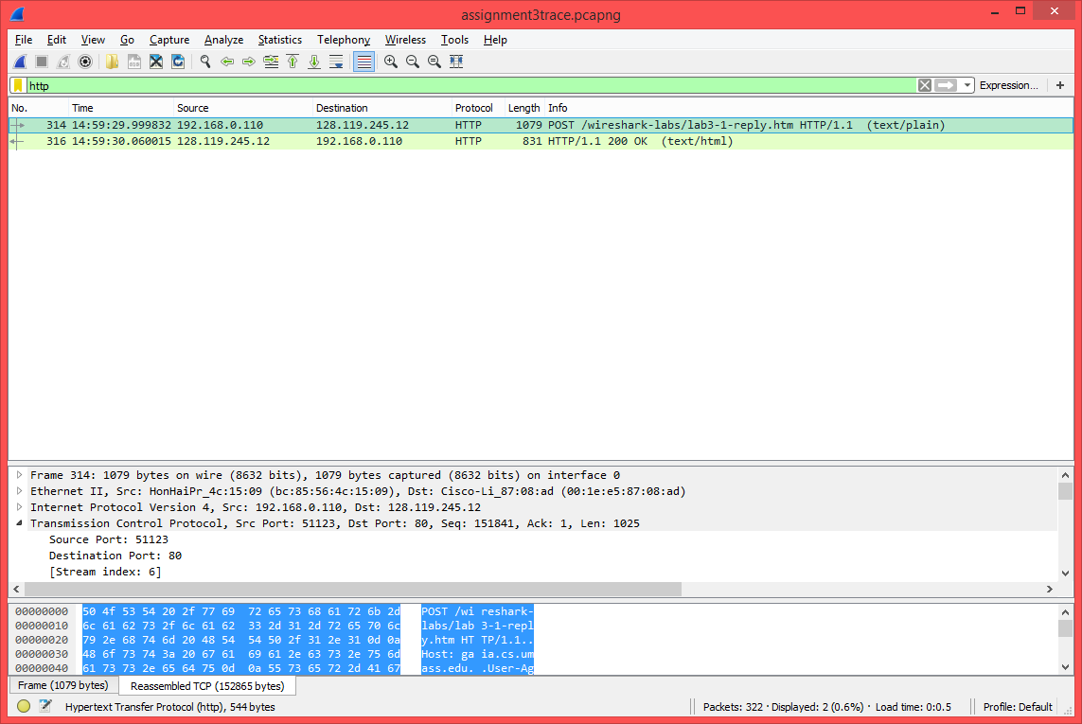

1. Sequence Number is 0 as seen in the info section and also seen in the packet details. In the info section, the label [SYN] identifies it as a SYN segment. Also, in the packet details, it is flagged as a SYN by the flag bit which equals 1.

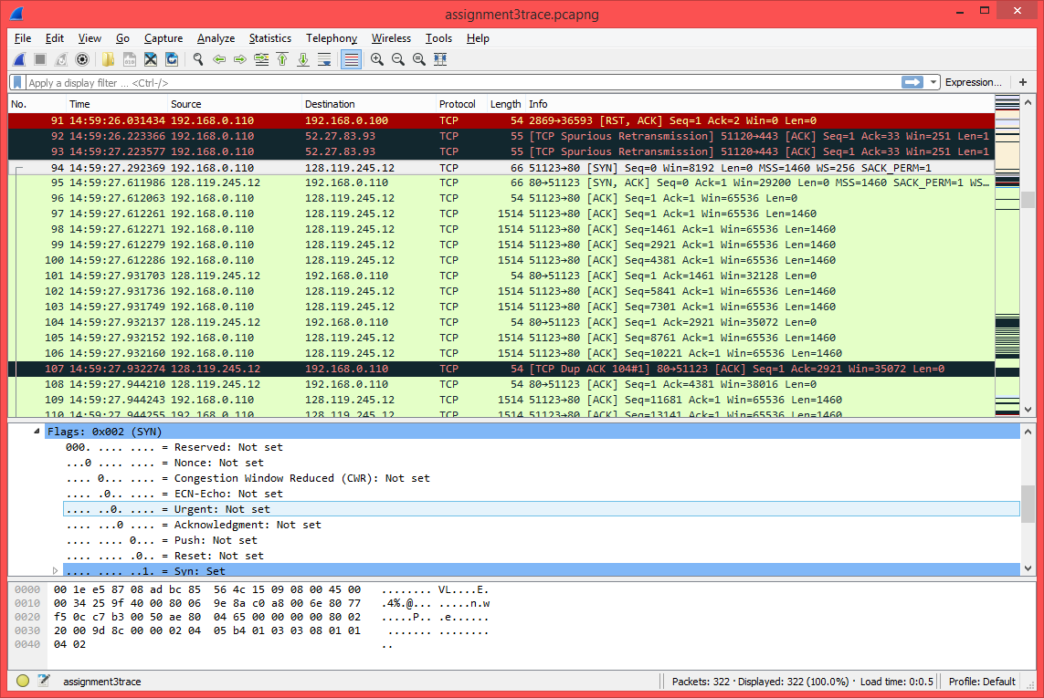

1. The sequence number of the SYNACK is also 0. The value in the acknowledgment field is 1 as it now expects the next segment sent to have sequence number 1 as something with sequence number 0 has already been received. The flag bits for SYN and ACK are 1 to show that the segment is a SYNACK segment.

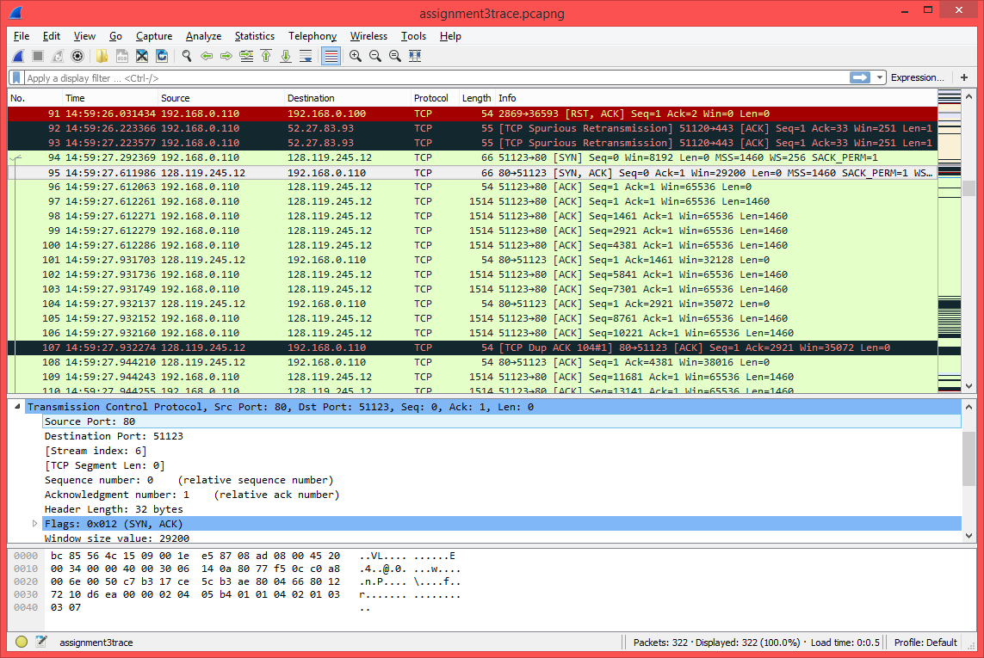

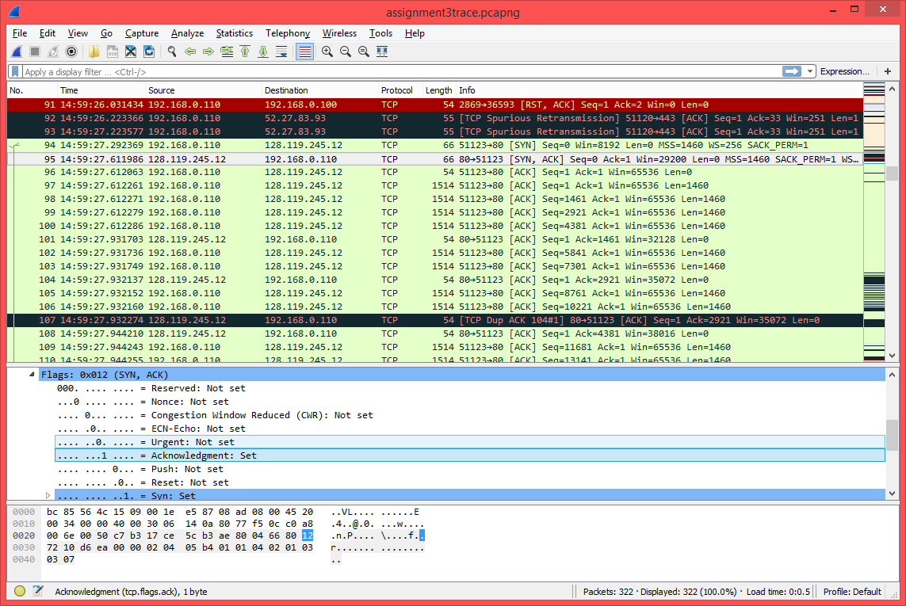

1. The sequence number is 151841 according to the screenshot below. I wasn’t actually sure if I was supposed to recheck HTTP in the analyze – enabled protocols section but that should still be a correct answer.

